Single variables across all sites

|  |  |  |  |  |  |  |  |  |  |  |  |  |  |  |
| --- | --- | --- | --- | --- | --- | --- | --- | --- | --- | --- | --- | --- | --- | --- |
|  | Low altitude | High altitude |  | Low chalk | High chalk |  | Shallow slopes | Steep slopes |  | East km | West km |  | North km | South km |
| 10th % (day) | 89**\*** | 90.1**\*** |  | 88.7**\*** | 92.2**\*** |  | 87.8**\*** | 91.9**\*** |  | 88.5**\*** | 90.8**\*** |  | 91.6**\*** | 88.4**\*** |
| Mean (day) | 112.9**\*** | 115.7**\*** |  | 112.7**\*** | 119.3**\*** |  | 111.4**\*** | 118**\*** |  | 113.5**\*** | 114.9**\*** |  | 114.3 | 114.0 |
| 90th % (day) | 130.9**\*** | 135**\*** |  | 130.7**\*** | 139.8**\*** |  | 129.2**\*** | 137.7**\*** |  | 132.4 | 132.9 |  | 130.9**\*** | 133.5**\*** |
| flight period (days) | 42**\*** | 44.9**\*** |  | 42**\*** | 47.6**\*** |  | 41.4**\*** | 45.9**\*** |  | 43.9**\*** | 42.1**\*** |  | 39.3**\*** | 45.1**\*** |

Table 1: Landscape factors of interest effects on phenology. **\*** represents significant difference

Table 2: All other landscape factors effects on phenology. * represents significant difference.

|  |  |  |  |  |  |  |  |  |
| --- | --- | --- | --- | --- | --- | --- | --- | --- |
| Factor | Arable % | |  | Bare Ground % | |  | Bracken % | |
| High | Low |  | High | Low |  | High | Low |
| Mean | 115.1536**\*** | 113.4192**\*** | | 115.1434 | 113.9144 |  | 112.6818 | 114.1731 |
| Range | 43.78372 | 42.77655 |  | 45.65208**\*** | 42.77447**\*** | | 38.55408**\*** | 43.47016**\*** |
| Start | 90.12207 | 89.03623 |  | 89.17292 | 89.49195 |  | 89.17292 | 89.49195 |
| End | 133.9058**\*** | 131.8128**\*** | | 134.825 | 132.2664 |  | 129.0464**\*** | 132.8491**\*** |
|  |  |  |  |  |  |  |  |  |
|  | Broadleaf % | |  | Coastal % | |  | Coniferous % | |
|  | High | Low |  | High | Low |  | High | Low |
| Mean | 113.323 | 114.6269 |  | 114.1488 | 114.0715 |  | 114.5658 | 113.9369 |
| Range | 43.17186 | 43.15079 |  | 40.17486**\*** | 43.4784**\*** |  | 42.76111 | 43.27594 |
| Start | 88.70272 | 89.99038 |  | 91.24711**\*** | 89.25725**\*** | | 90.05802 | 89.27161 |
| End | 131.8746 | 133.1412 |  | 131.422 | 132.7356 |  | 132.8191 | 132.5476 |
|  |  |  |  |  |  |  |  |  |
|  | Fen/bog % | |  | Garden % | |  | Grass % | |
|  | High | Low |  | High | Low |  | High | Low |
| Mean | 116.098 | 113.9217 |  | 110.7204**\*** | 115.3795**\*** | | 115.1144**\*** | 113.1713**\*** |
| Range | 44.33784 | 43.06793 |  | 43.01449 | 43.21586 |  | 44.34716**\*** | 42.11879**\*** |
| Start | 90.55019 | 89.36354 |  | 86.31868**\*** | 90.66151**\*** | | 89.82448 | 89.12036 |
| End | 134.888 | 132.4315 |  | 129.3332**\*** | 133.8774**\*** | | 134.1716**\*** | 131.2391**\*** |
|  |  |  |  |  |  |  |  |  |
| Factor | Heath % | |  | Lowland Meadow % | |  | Montaine % | |
| High | Low |  | High | Low |  | High | Low |
| Mean | 114.4149 | 114.0353 |  | 111.2676**\*** | 114.3078**\*** | | 119.3653 | 114.0575 |
| Range | 42.45874 | 43.25063 |  | 42.25185 | 43.23356 |  | 39.65517 | 43.17388 |
| Start | 90.03398 | 89.37335 |  | 87.44444 | 89.61248 |  | 95.89655 | 89.42307 |
| End | 132.4927 | 132.624 |  | 129.6963 | 132.846 |  | 135.5517 | 132.5969 |
|  |  |  |  |  |  |  |  |  |
| Factor | River % | |  | Orientation | |  |  | |
| High | Low |  | North | South |  |  |  |
| Mean | 111.9711 | 114.3395 |  | 113.7144 | 114.4712 |  |  |  |
| Range | 41.1711 | 43.40545 |  | 42.60898 | 43.65854 |  |  |  |
| Start | 88.36755 | 89.58295 |  | 89.4497 | 89.5008 |  |  |  |
| End | 129.5387 | 132.9884 |  | 132.0587 | 133.1593 |  |  |  |

Multiple variables

Chalk % and slope angle

1. Mean flight days are Latest on high chalk steep slopes (day 121.7). Earlier on high chalk, shallow slopes and low chalk steep slopes (day 115.8) and earliest on low chalk, shallow slopes (day 111.0) (Figure 1A).
2. Flight period is longest on steep slopes with high chalk (49.3 days), followed by steep slopes with low chalk (44.0 days). Shallow slopes had the shortest flight period regardless of chalk (41.4 days) (Figure 1D).
3. Flight period start dates (10th percentile) are earliest on low chalk slopes regardless of altitude (day 88.7), followed by high chalk, low alt (day 89.9). Latest on high chalk, high altitude slopes (day 94.1) (Figure 1C).
4. Flight period end dates (90th percentile) are earliest on low chalk, shallow slopes (day 128.6), followed by high chalk, shallow slopes (day 134.2), followed by low chalk, steep slopes (day 135.1). Latest on high chalk, steep slopes (day 142.8) (Figure 1D).

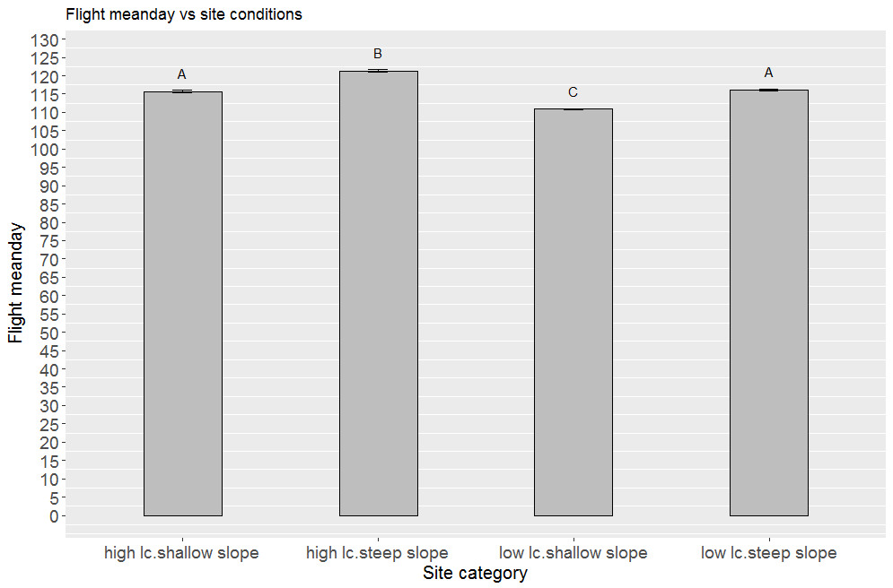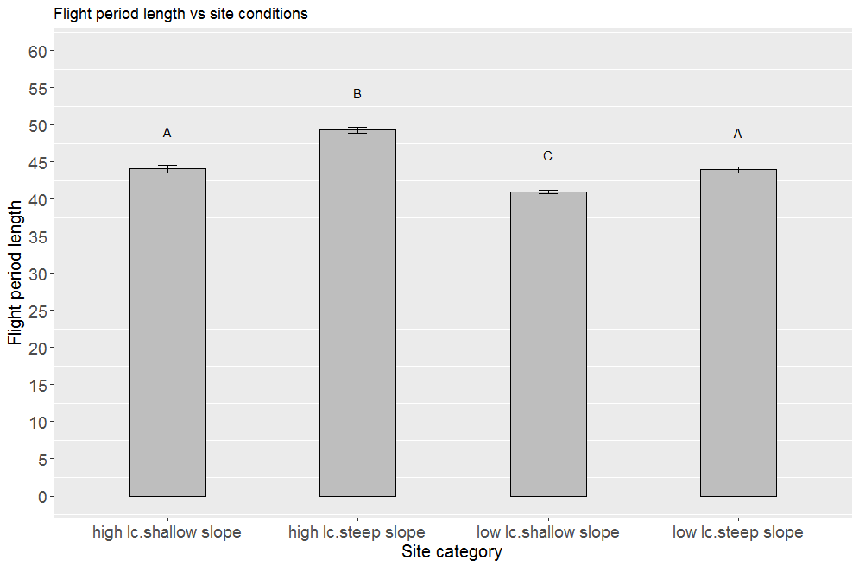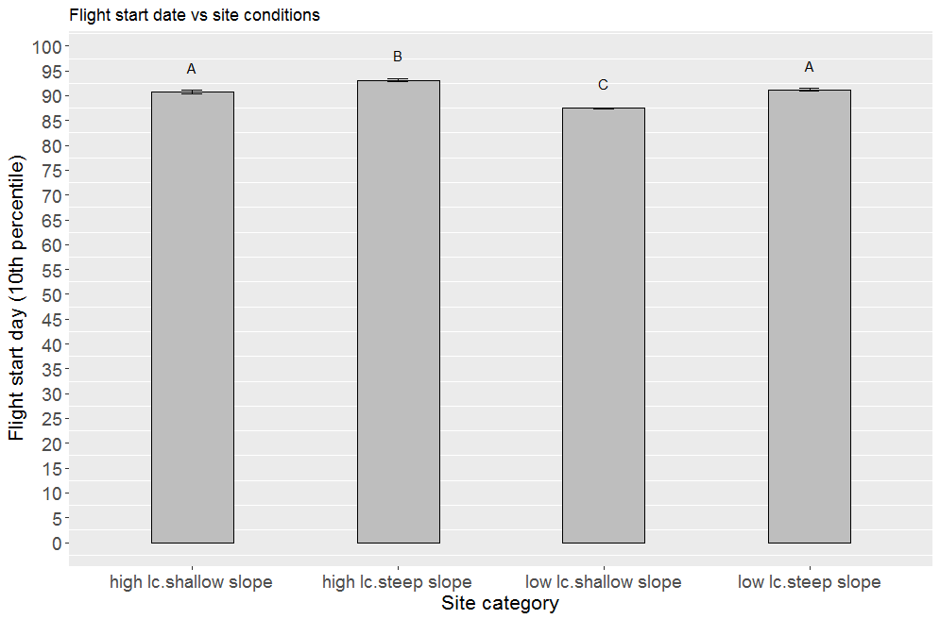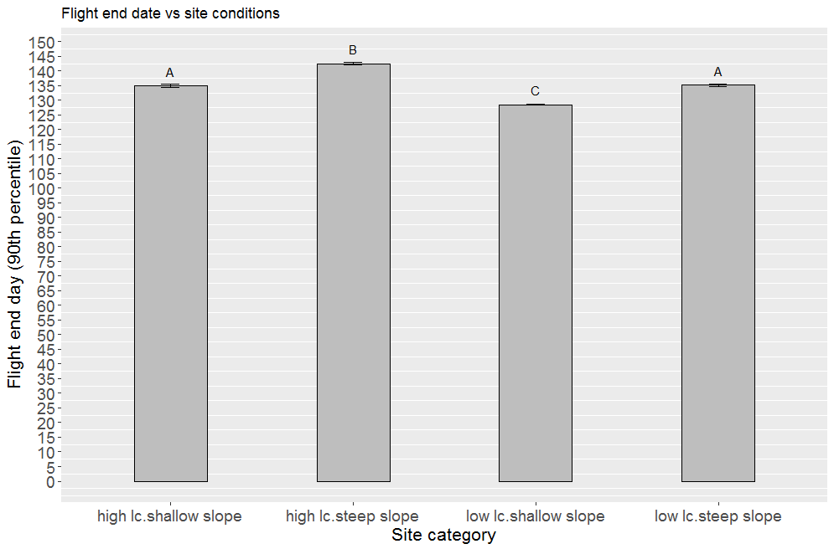

A

B

C

D

Figure 1. Slope angle and chalk percentage vs phenology. Letters indicate significance groupings.

Altitude and chalk %

* Mean flight days are latest on high chalk at high altitudes (day 123.3) vs high chalk at low altitude (day 114.3) and earliest on low chalk sites regardless of altitude (day 112.7) (Figure 2A).
* Flight period is longer on high chalk low altitude sites (51.3 days) than all others (42.1 days) (Figure 2B).
* Flight period start dates (10th percentile) are earliest on low chalk, shallow slopes (day 87.6) followed by high chalk, shallow slopes (day 89.9) followed by low chalk, steep slopes (day 91.0) with high chalk, steep slopes latest (day 93.5) (Figure 2C).
* Flight period end dates (90th percentile) are earlier at all sites (day 130.9) vs high chalk, high altitude (day 145.3) (Figure 2D).

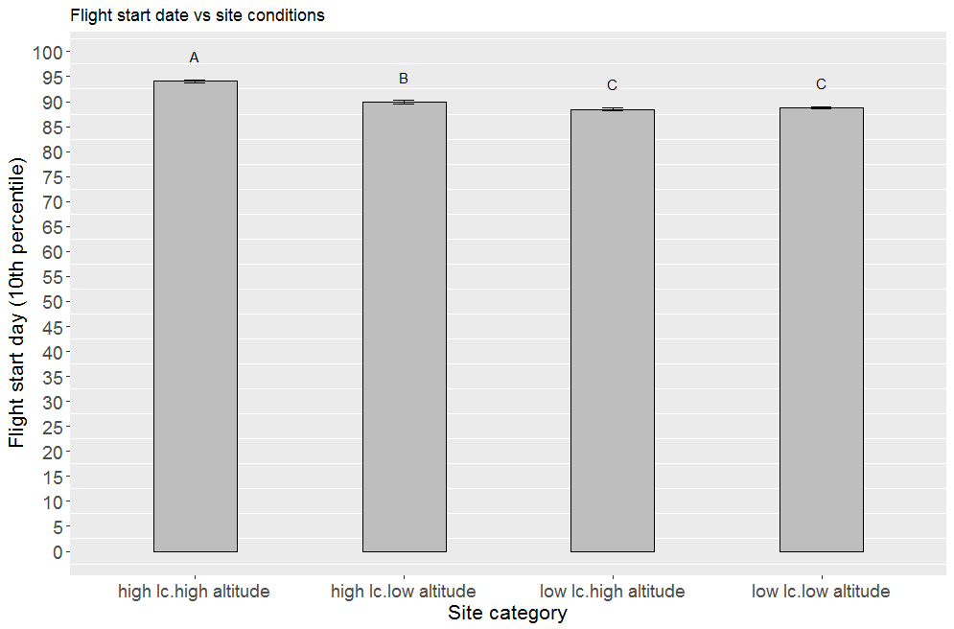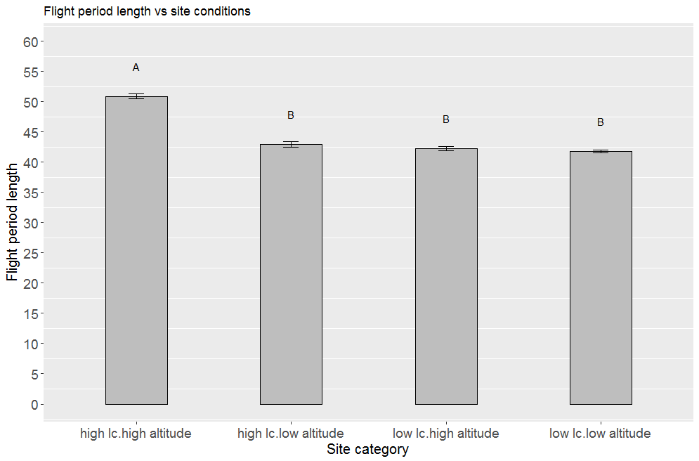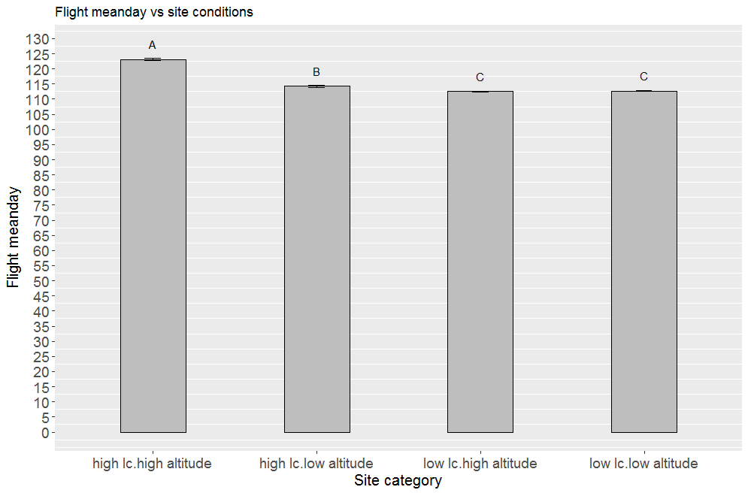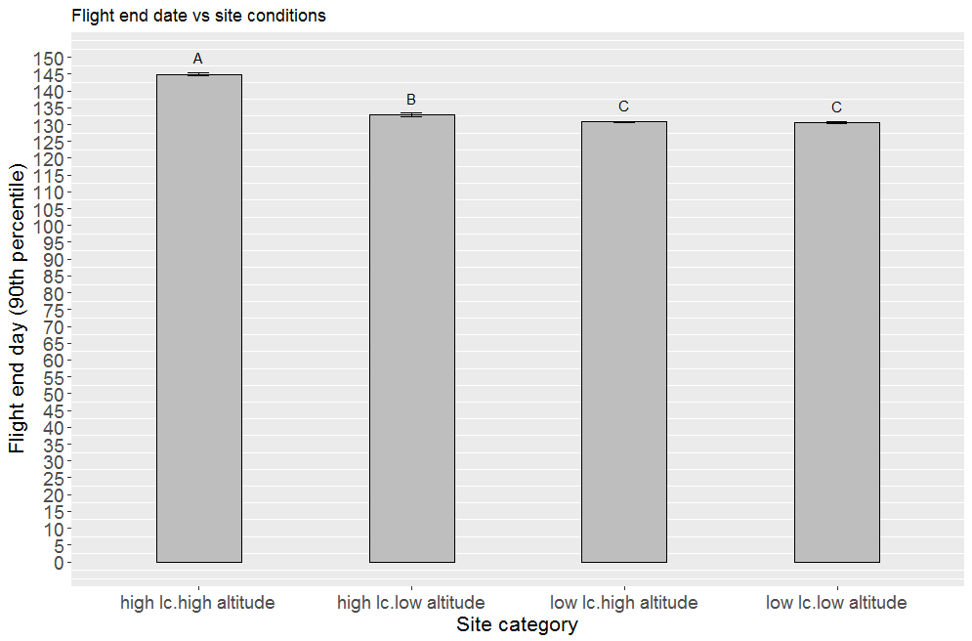

A

B

C

D

Figure 2. Altitude and chalk percentage vs phenology. Letters indicate significance groupings.

High altitude sites had longer seasons than low altitude sites? Would expect lower altitudes to be warmer?

Slope Angle and Altitude

* Mean flight days are later on steep slopes regardless of altitude (day 118.0) vs shallow slopes regardless of altitude (day 111.5) (Figure 3A).
* Flight period is longest on steep slopes at high altitude (47.1 days), followed by low altitude steep slopes (44.2 days) and shortest on shallow slopes both high and low altitude (41.4 days) (Figure 3B).
* Flight period start dates (10th percentile) are earliest on shallow slopes regardless of altitude (day 87.8) vs steep (day 91.9) (Figure 3C).
* Flight period end dates (90th percentile) are earlier on shallow slopes regardless of altitude (day 129.2) vs steep slopes regardless of altitude (day137.7) (Figure 3D).

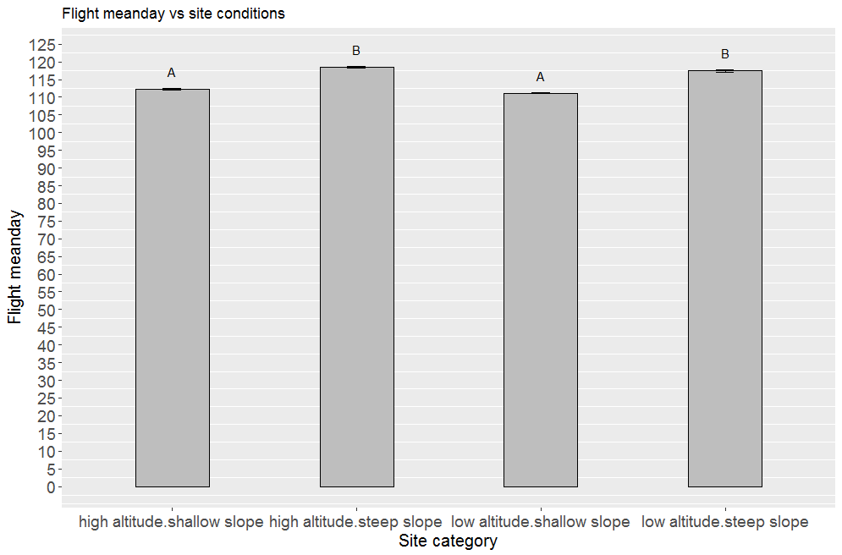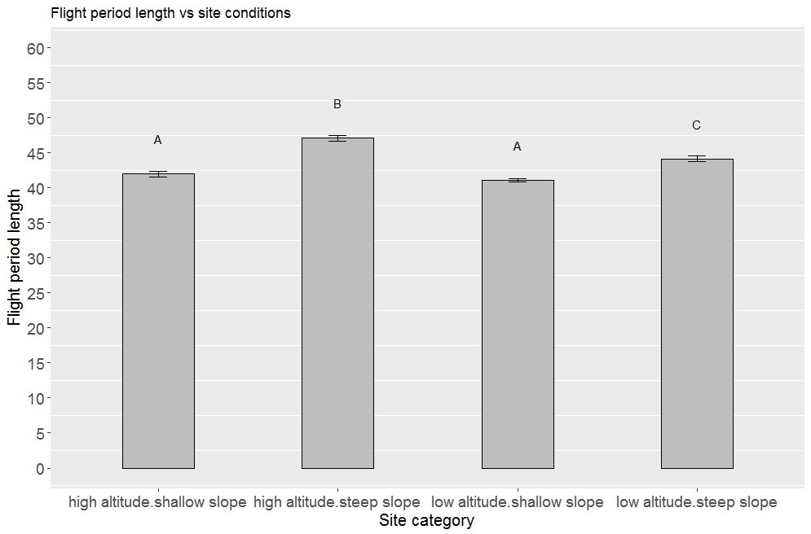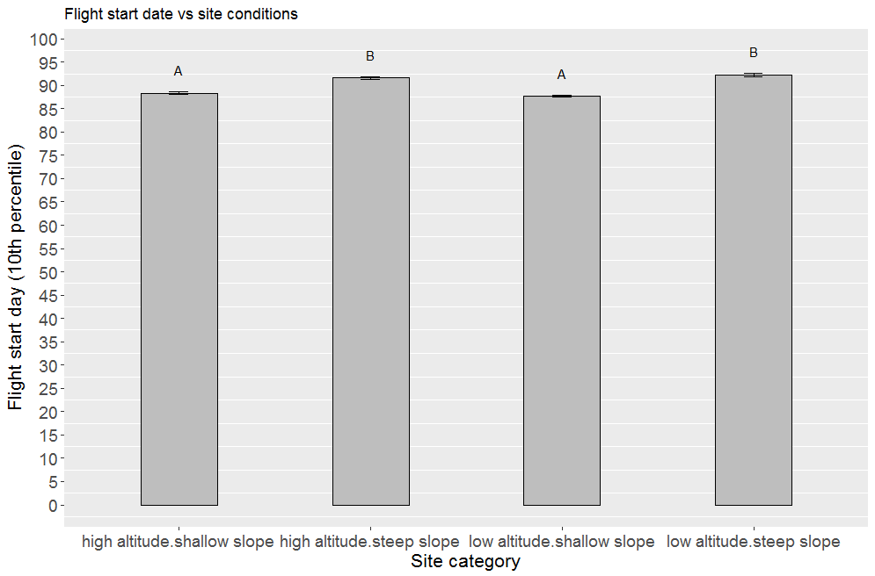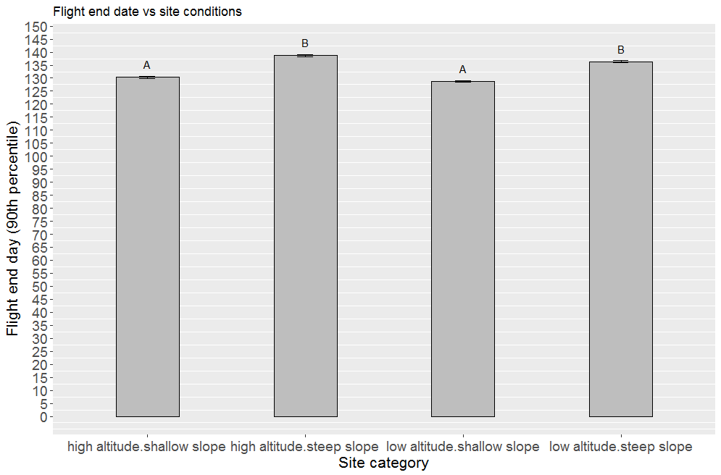

Figure 3. Altitude and slope angle vs phenology. Letters indicate significance groupings.

A

B

C

D

Slope angle has a greater effect than altitude.

Site location

* Mean flight days are latest at all other sites (day 114.7) vs northern western sites (day 113.4) (Figure 4A).
* Flight period is longest at northern.weston & southern.western sites (45.1 days) vs northern.eastern & southern.eastern sites (39.3 days) (Figure 4B).
* Flight period start dates (10th percentile) are earliest at northern.western sites (day 87.8), followed by northern eastern & southern western (day 90.3). Latest at southern eastern sites (day 91.8) (Figure 4C).
* Flight period end dates (90th percentile) are earliest at all other sites (day 132.0) vs southern.western (day 135.0) (Figure 4D).

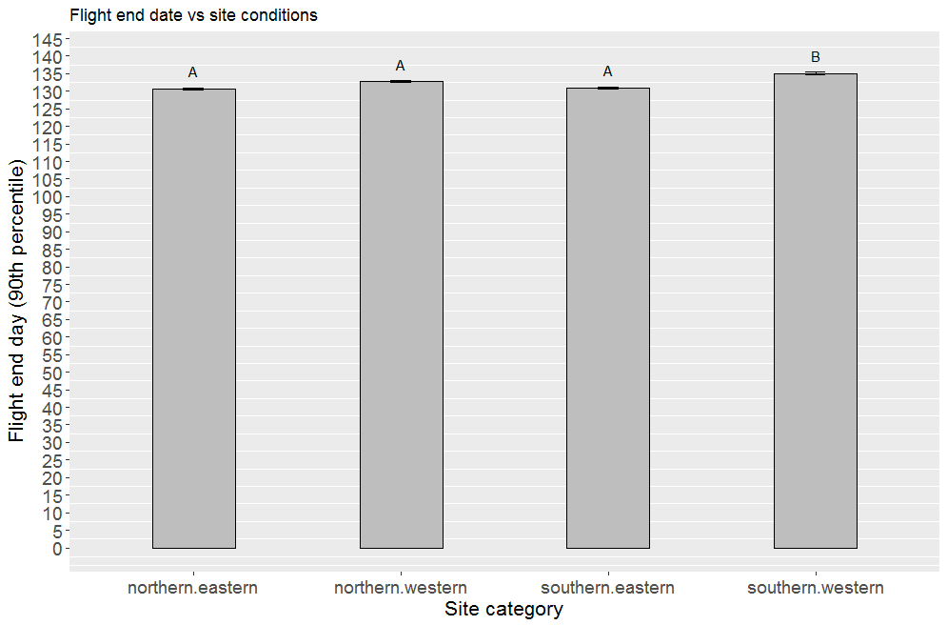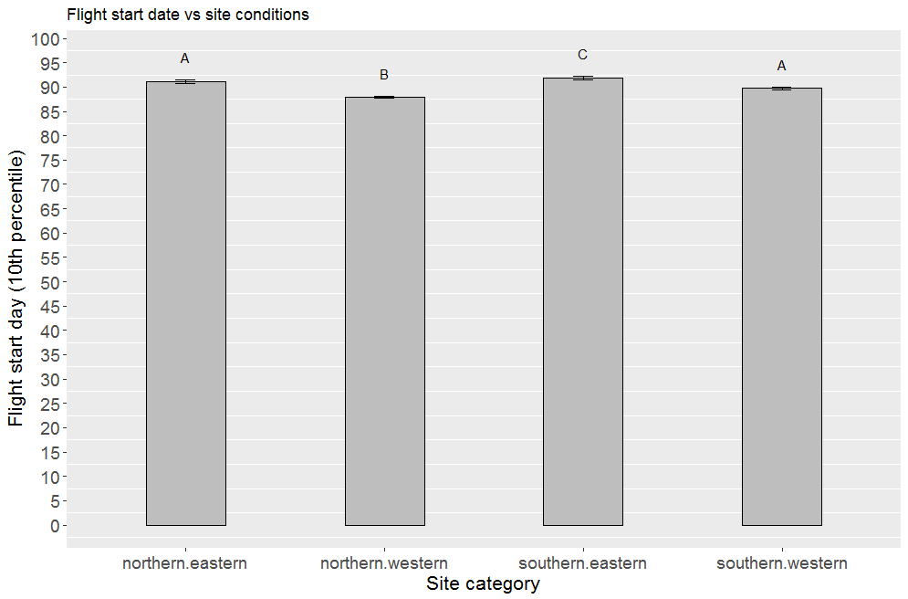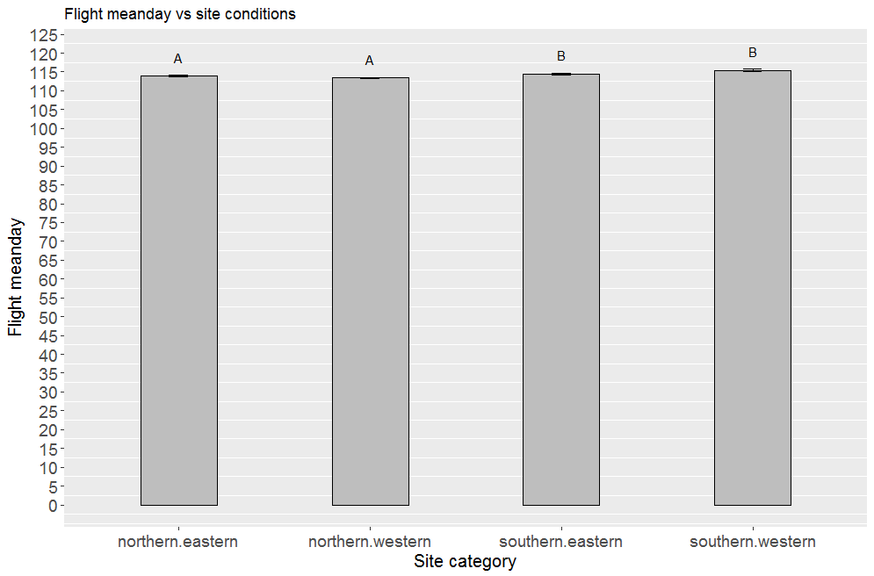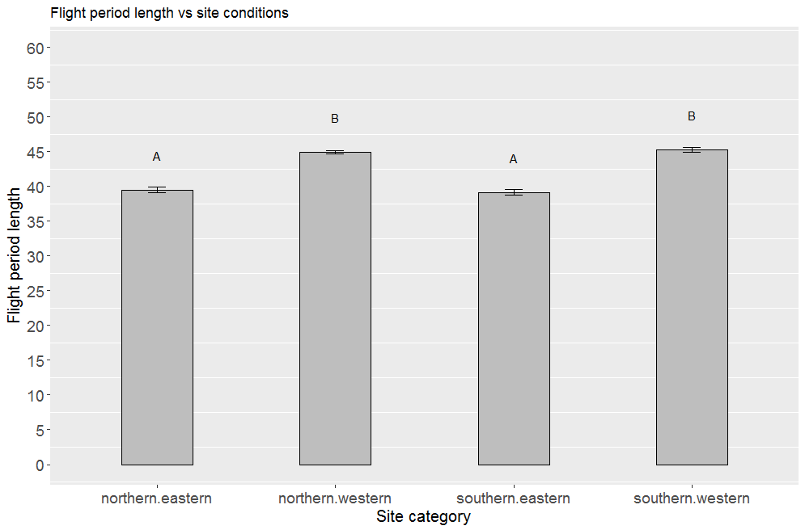

Figure 3. Site location (easting and northing) vs phenology. Letters indicate significance groupings.

A

B

C

D

Temperature analysis

Table 3. Comparison of phenology in a hot year (2003, 17.3˚C) and a cold year (2011, 14.8˚C) on steep high chalk sites.

|  |  |  |
| --- | --- | --- |
|  | 2003 | 2011 |
| Flight period mean day | 115.20* | 119.44* |
| Flight period range | 47.90* | 55.56* |
| Flight period start day | 87.32 | 87.44 |
| Flight period end day | 135.22* | 143.00* |

Table 3. Comparison of phenology in a hot year (2003, 17.3˚C) and a cold year (2011, 14.8˚C) on shallow low chalk sites.

|  |  |  |
| --- | --- | --- |
|  | 2003 | 2011 |
| Flight period mean day | 106.88 | 105.31 |
| Flight period range | 40.948* | 49.37* |
| Flight period start day | 83.40* | 78.29* |
| Flight period end day | 124.34* | 127.66* |

Cooler year has longer flight period than hotter year. Started and finished earlier.

Confuses results that flight periods longer on chalk steep slopes. Was assumed this was because sites are warmer.